**8-BIT SUBTRACTION:**

**EXP NO:2**

**AIM:**To write an assembly language program to implement 8-bit addition using 8085  
processor.

**APPARATUS:** GNUSim8085

**ALGORITHM:**

1)Start the program by loading the first data into the accumulator.  
2) Move the data to a register.  
3) Get the second data and load it into the accumulator.  
4) Subtract the two register contents.  
5) Check for borrowing.  
6) Store the difference and borrow it in the memory location.  
7) Halt.   
**PROGRAM:**

  LDA 8000  
  MOV B, A  
  LDA 8001  
  SUB B  
  STA 8002

RST 1  
**INPUT:**

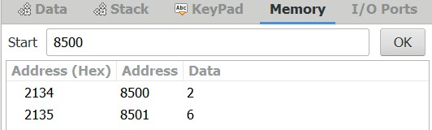

**OUTPUT:**

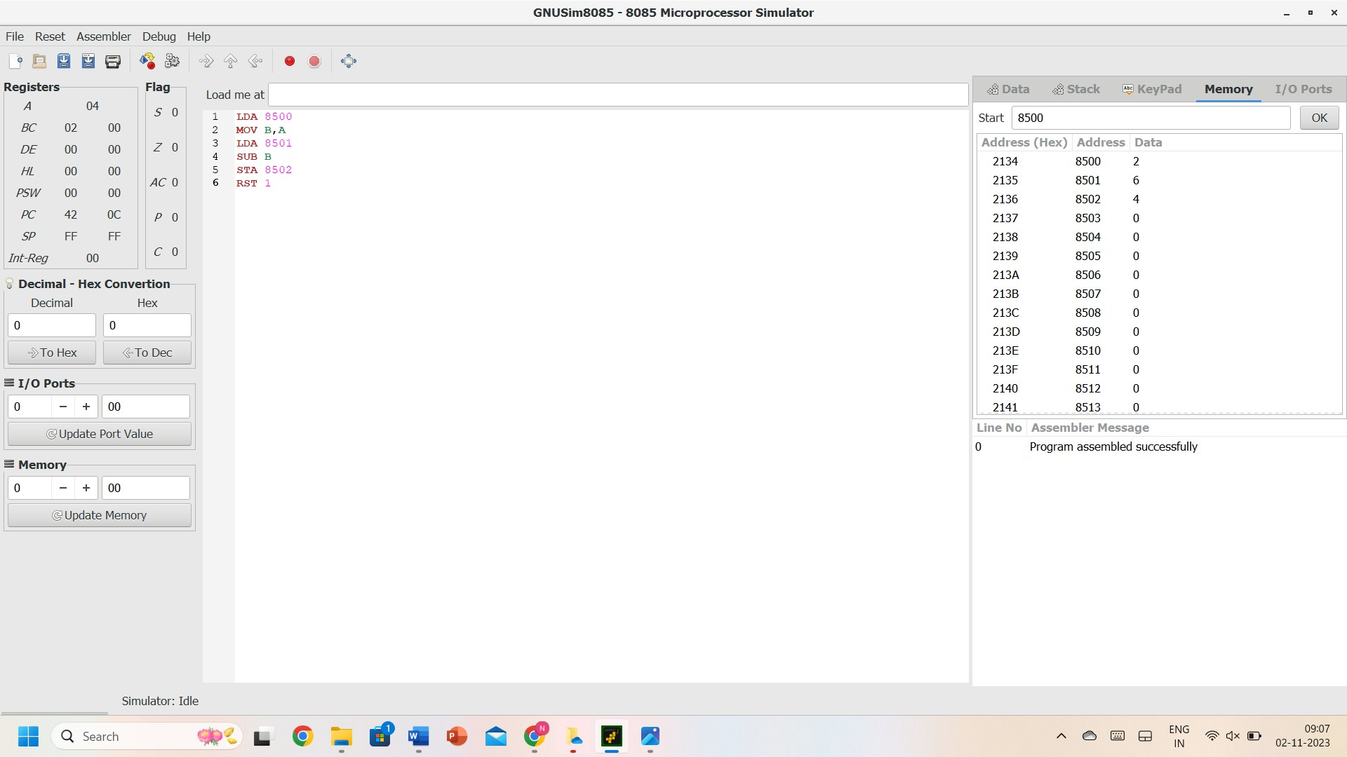

**RESULT:** Thus, the program was executed successfully using 8085 processor simulators.